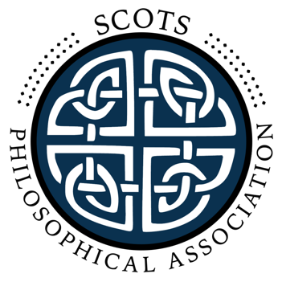

Conference and Annual General Meeting 2023, University of Edinburgh

Thursday 7th December

Bayes Centre – G.03

15.00-15.30 Coffee and welcome

15.30-17.00 Alex Douglas (St. Andrews)
“Pythagorean naturalism? Spinoza's ontology as a system of mathematical objects”

Friday 8th December

Bayes Centre – G.03

9.00-10.30 Jennifer Corns (Glasgow)
“Psychiatric Kinds”

10.30-11.00 Coffee

11.00-12.30 Katie Robertson (Stirling)
“Naturalism and philosophy of physics”

12.30-13.15 Lunch

13.15-14.30 Panel discussion on naturalism with Debbie Roberts (Edinburgh), Michael Wheeler (Stirling) and Jo Wolff (Edinburgh).

15.00-16.30 Annual General Meeting in Dugald Stewart Building, 7.01

Abstracts

Alex Douglas (St. Andrews)
Pythagorean naturalism? Spinoza's ontology as a system of mathematical objects

Spinoza is often characterised as a philosphical naturalist. This label captures something true about Spinoza: he believed in an inviolable order of natural laws, ruling out miracles and supernatural entities capable of violating the laws of nature. But the label carries misleading connotations in the contemporary context. Whereas contemporary naturalists tend to think of a natural order discoverable through the special sciences, Spinoza, I argue, regarded it as more like a system of mathematical objects: existing necessarily, discoverable by the pure intellect, and thus, in contemporary terms, more abstract than concrete. In other words, I present Spinoza as a sort of Pythagorean, who views the world as an abstract or mathematical object. This is far from what the typical supernaturalist thinks but also far from what the typical naturalist thinks.

